**Lab 01 - Building your first copilot with Copilot**

**Studio**

Lab Type – Instructor Led

Duration – 25 minutes

**Objective:**

In this lab, you go through the steps of creating, deploying, and testing your first copilot to handle a common customer request.

# Exercise 1: Build your first copilot

## Task 1: Sign in to create a copilot

1. From an in-private or incognito browser, open the url - [https://copilotstudio.microsoft.com/.](https://copilotstudio.microsoft.com/)
2. Sign in with the login credentials provided by your lab instructor.

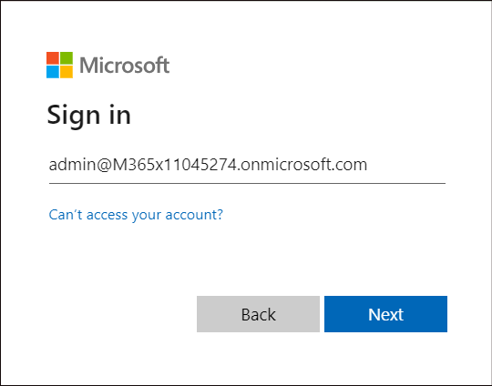

1. Once logged in, the Welcome to Microsoft Copilot Studio page will pop up. Select your Country and click on **Start free trial**.

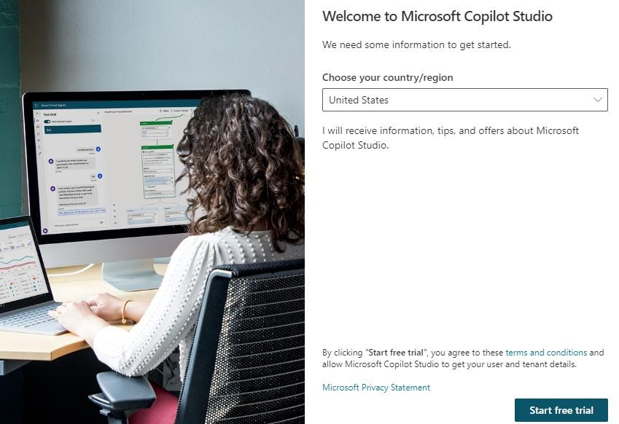

1. Feel free to click through the tutorial on the new Copilot Studio or click on Skip.

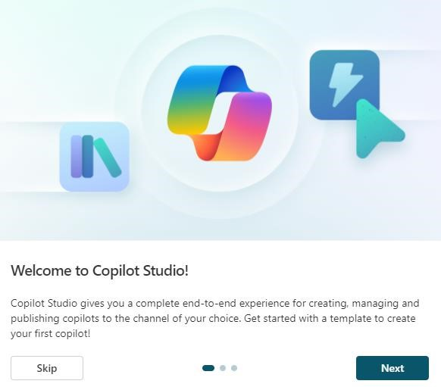

1. Click on **+ Create** then **New copilot** to get started creating your first copilot.

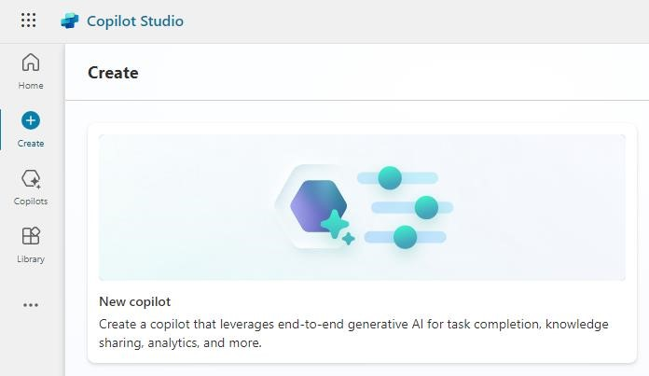

1. The Copilot Studio opens to the screen to create your first copilot. In the message area type: **Create a customer service bot that will help end users with order details and order processing** and then click the **Send** button**.**

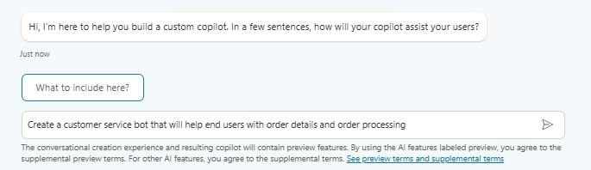

1. Continue setting up the copilot using the chat functionality with the following information:

Tone: **Use a professional and friendly tone.**

Any Tips?: **None**

Topics to Avoid: **Financial information.**

*We will add Knowledge Articles in a later lab.*

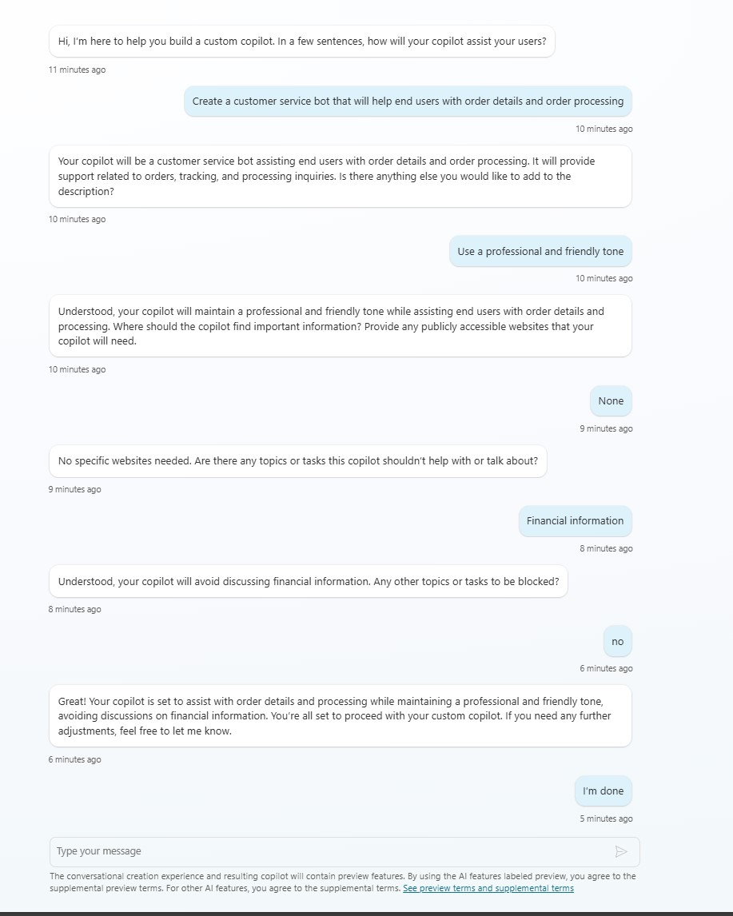

1. We are now ready to create our copilot. In the upper right corner, click on **Create.**

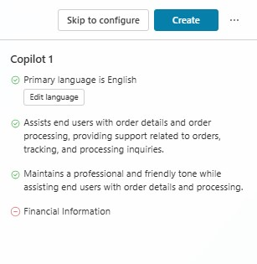

1. The setting up of the copilot will take a few minutes for the first time. A message on the screen will pop up.

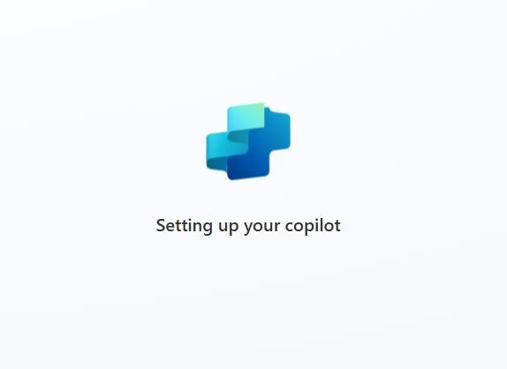

1. Edit the details of the copilot. We can change the name, icon, description and instructions for the copilot after it is created. Let’s change the name of the copilot to Customer Service Copilot_XX (where XX are your initials). Click on **Edit.**

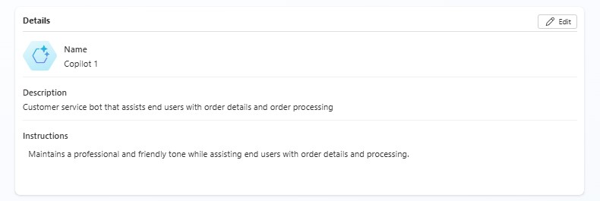

1. Change the name of the copilot to **Customer Service Copilot_XX** and then click on **Save.**

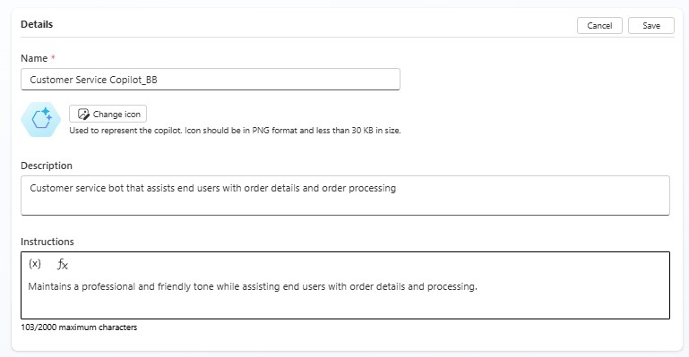

## Task 2: Take a quick tour of the user interface

You are currently on the Overview tab.

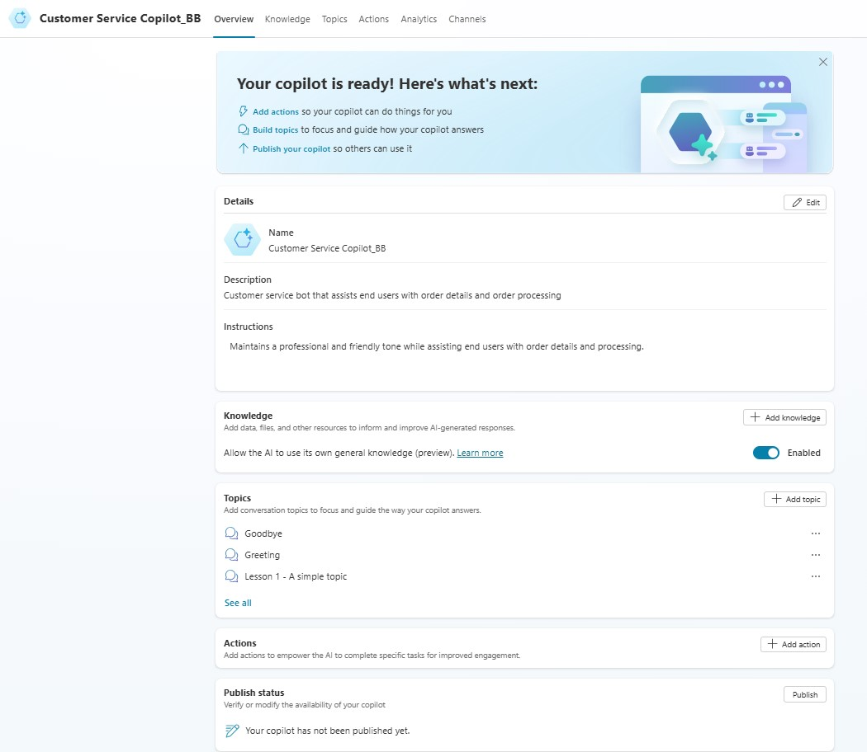

Click on the **Knowledge, Topics, Actions, Analytics and Channels tabs** to view the configuration capabilities. We will be adding sources to the Knowledge section and Actions in another lab.

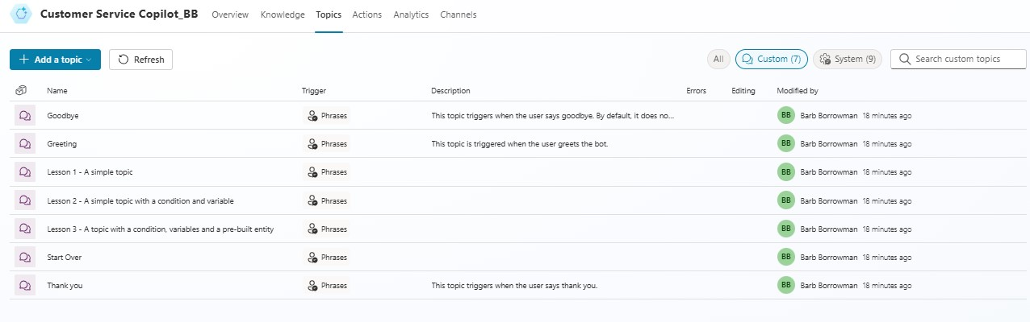

[Knowledge sources overview - Microsoft Copilot Studio | Microsoft Learn](https://learn.microsoft.com/en-us/microsoft-copilot-studio/knowledge-copilot-studio)

[Use lesson topics - Microsoft Copilot Studio | Microsoft Learn](https://learn.microsoft.com/en-us/microsoft-copilot-studio/authoring-template-topics?tabs=web)

[Use Power Platform connectors (preview) - Microsoft Copilot Studio | Microsoft Learn](https://learn.microsoft.com/en-us/microsoft-copilot-studio/advanced-connectors)

[Use actions with custom copilots (preview) - Microsoft Copilot Studio | Microsoft Learn](https://learn.microsoft.com/en-us/microsoft-copilot-studio/advanced-plugin-actions)

[Fundamentals - Analyze copilot usage (contains video) - Microsoft Copilot Studio | Microsoft Learn](https://learn.microsoft.com/en-us/microsoft-copilot-studio/analytics-overview)

[Fundamentals - Publish a chatbot to various channels (contains video) - Microsoft Copilot Studio | Microsoft Learn](https://learn.microsoft.com/en-us/microsoft-copilot-studio/publication-fundamentals-publish-channels?tabs=web)

**Task 3: Try out a conversation in the Test your copilot pane.**

Now let's try out the copilot using one of the four pre-built lessons included when you create a new copilot.

1. On the right-hand side of the screen is the pane to Test your copilot. To follow along on a node-by-node basis as the copilot executes your dialog, select the **More icon** **(...)** in the Test your Copilot pane and turn on **Track between topics**. *This will switch us over to the Topics tab if you are not already there.*

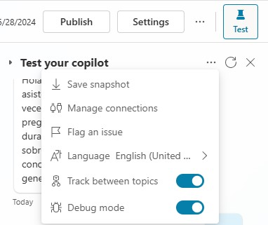

1. At the **Type your message** prompt at the bottom of the Test copilot, type: **Hello** and then select the **Send** button.

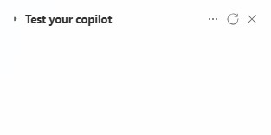

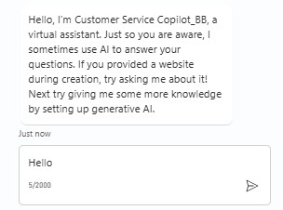

The copilot offers a greeting in the Test copilot pane.

You can see the greeting topic open in the authoring canvas window, with green outline and a checkmark added for each part of the conversation design when it's used in the test chat. (This is what the **Tracking** feature does; if you didn't turn this on, you don't see any changes to the page selection and you see the green highlights in the greeting topic only if you already opened it from the Topics page.)

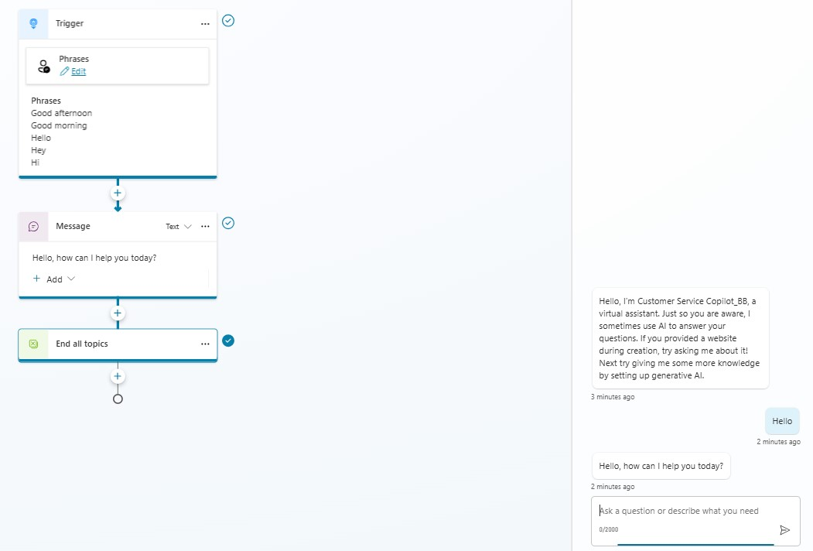

1. In the Test copilot, enter the following message and press Send **stores near me**.

Notice that a new topic opens in the authoring canvas. You have triggered one of the prebuilt topics (Lesson 2).

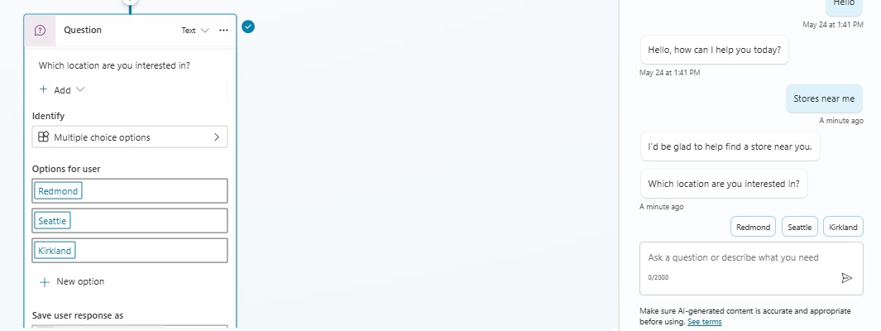

1. Now, in the test chat, pick the store location you want and observe that the copilot answers with a store address in that location.

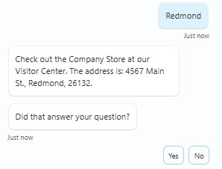

# Exercise 2: Edit your conversation

Now, let's make a change to that conversation by adding another store location. We make a copy first so that later you can go back to the Lessons as they were written if you want to.

## Task 1: Make a copy of the topic

1. At the top right hand of the page, select **Test** to put the Test copilot out of your way for now.



1. From the top ribbon, select the **Topics** tab to open the **Topics** list.

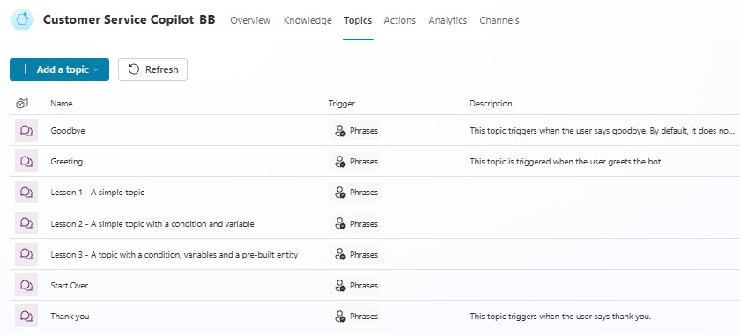

1. Hover your mouse over the row for the prebuilt topic **Lesson 2 - A simple topic with a condition and variable**. Select the **More actions (…)** icon, then **Make a copy**.

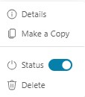

The Topics page opens with the copied version of the lesson.

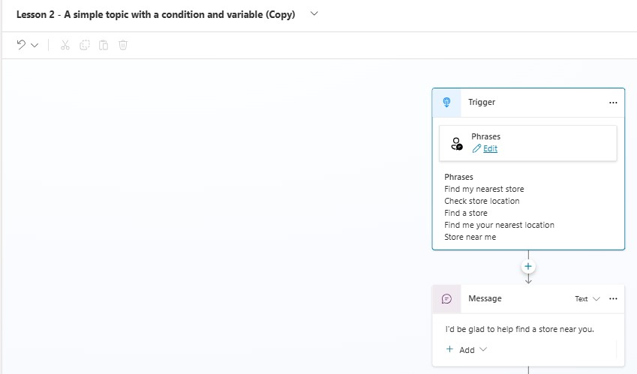

## Task 2: Edit the copy of the topic

1. You're now looking at the **Setup** page for the copied topic. This page is where you enter the topic **Name** (which appears to your customers), **Description** (which doesn't appear to your customers but is for your own use), and **Trigger phrases**.
2. Select the current text in the **Name** field, delete it, and type to rename the topic to “**Get store locations”**.

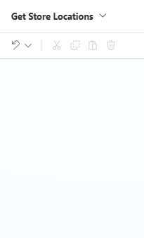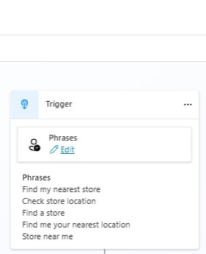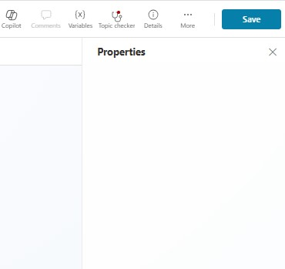

Let's imagine you opened a new store in Bellevue. To add the store info to your copilot, you need to edit the topic design in the authoring canvas. The authoring canvas contains all the text and logic for the conversation about store locations. At the top, you see a reminder of the trigger phrases, which are added and edited on the Setup page.

1. Scroll down the page to see the conversation design.

Each of the connected boxes you see is called a "node." You can see that the copilot displays a message in a **Message** node that it would be glad to help find a store location and then asks in a **Question** node which location the user is interested in. (You can reopen the Test copilot to see that this is the same as the conversation you had in Exercise 1. Then close the Test copilot again.)

1. Scroll to the Question node that asks "Which location are you interested in?" We're going to add another option here.

**Note:** If the already existing nodes has got **Incompatible type comparison error**, click on the **Object** field and select one location in a node, ensuring that all the 3 existing locations are available in one condition node.

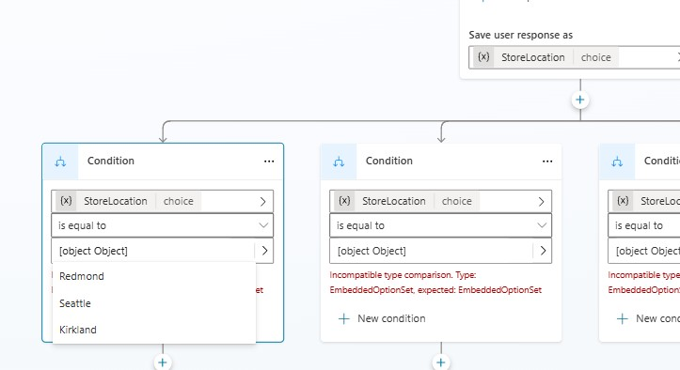

1. Under "Redmond" "Seattle" "Kirkland," select **+ New option**.

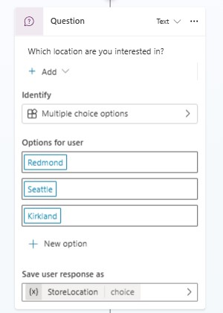

A new **Condition** node is added under the Question node.

1. In the Question node (**NOT** in the Condition node), type **Bellevue** in the newly added empty box under **Options for user**.

**Bellevue** is automatically added for you in the Condition node too.

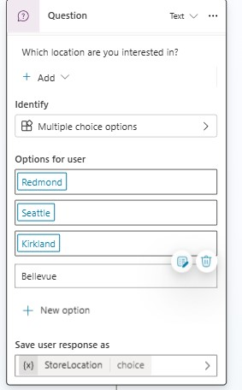

**Note**

The **Options for user** section controls what buttons are visible to users in the chat window, and always need to be matched with a condition, or the button won't work. The Conditions, however, can handle the user typing something that is not shown in a button. So for instance if you were to delete the Bellevue **Options for user** button, it would not delete the Bellevue Condition node, which would be used if the user types "Bellevue" when asked for a location.

Now tell the copilot what message to display if the user selects **Bellevue**.

1. Select the **+ icon** underneath the Bellevue condition node.

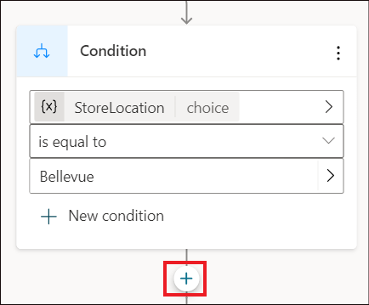

1. From the options that appear, select **Send a message**.

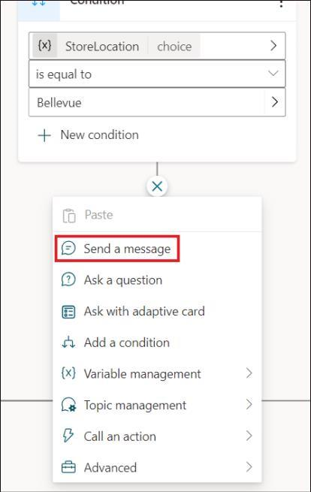

This adds a new Message node connected to the Bellevue condition.

1. In the Message node, enter the store location info: **Our Bellevue store is at 1234 Bellevue Way, Bellevue, WA 98123.**

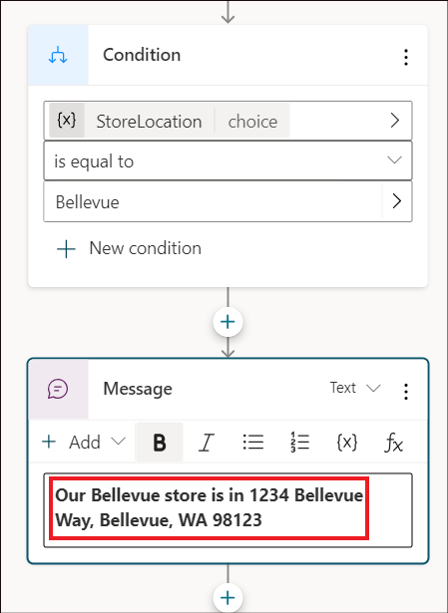

**Note:**

You can format the message text using the formatting buttons that appear while you're typing. You can even replace the name of the location with the variable ~ *StoreLocation.*

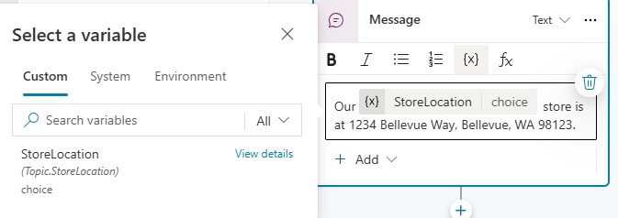

You're now going to end the conversation. Since the conversation ends the same way no matter which location the user chooses, we're going to link to a shared End of conversation node. This node starts the End of conversation system topic.

1. First, zoom out if necessary to see the End of conversation node on your screen.

(**Zoom out** is in the utility bar on the left of the authoring canvas.)

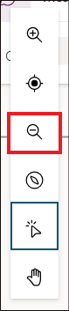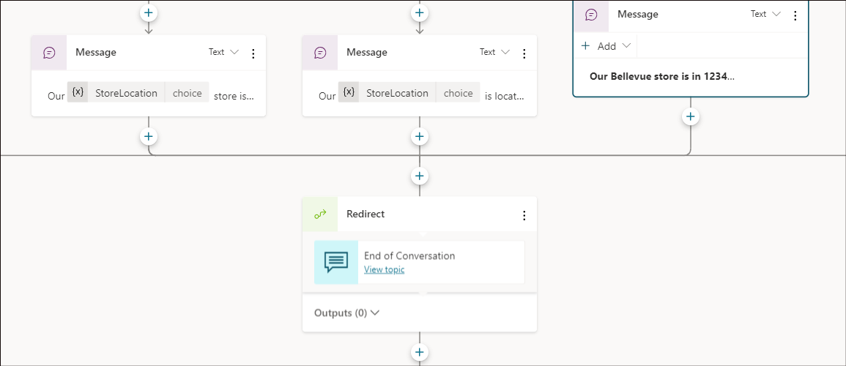

11. At the top right of the page, select **Save** to save the changes you made.

## Task 3: Turn on your topic and test your changes

You might recall that when we made a copy of the Lesson 2 topic, the copy was created in an Off state. This means you can't trigger the topic in the test copilot (and if you published your copilot, your users couldn't trigger it either). We're ready to turn on the edited topic now.

1. Select the **Topics** tab in the top ribbon to return to the Topics list.
2. Select the **Status** toggle from On to **Off** for **Lesson 2 - A simple topic with a condition and variable** and select the **Status** toggle from Off to **On** for **Get store locations**. Now, you can test the conversation you edited.

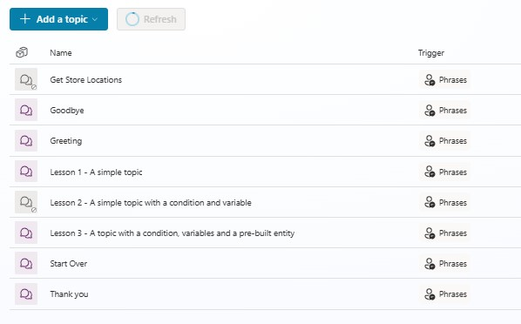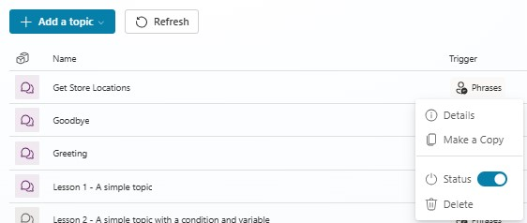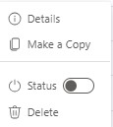

1. In the upper-right corner of the page, select **Test.** Make sure the **Track between topics** toggle is set to the **On** position. In the test copilot, enter **Is there a store near me?** and select the **Send** button.

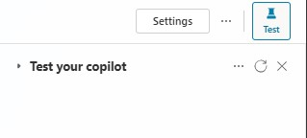

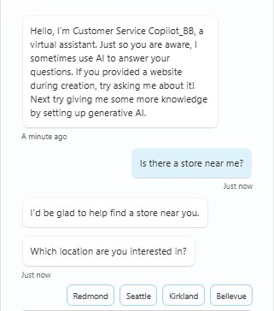

Notice that even though it isn't exactly the same as the trigger phrases in the topic, "Is there a store near me?" works to trigger the topic because Microsoft Copilot Studio understands that it means the same thing as the trigger phrases.

1. When asked to select a location, select the **Bellevue** location in the test chat. (You might need to use the onscreen right arrow to see the Bellevue option.)

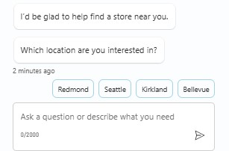

The copilot replies with location info for Bellevue store. Notice that the conversation continues in the **End of conversation** system topic. Feel free to keep chatting with the test copilot.

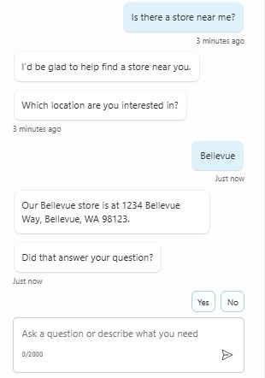

**Exercise 3: Publish your copilot to the demo site for testing**

Microsoft Copilot Studio provides a demo website so that you can invite anyone to test your copilot by sending them the URL. This demo website is useful to gather feedback to improve the copilot content before you activate the copilot for your real customers.

1. We need to change our authentication to enable the demo website. With your Customer Service copilot still selected, click on **Settings** in the upper right.

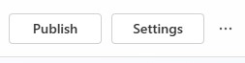

1. Click on **Security** then **Authentication**.

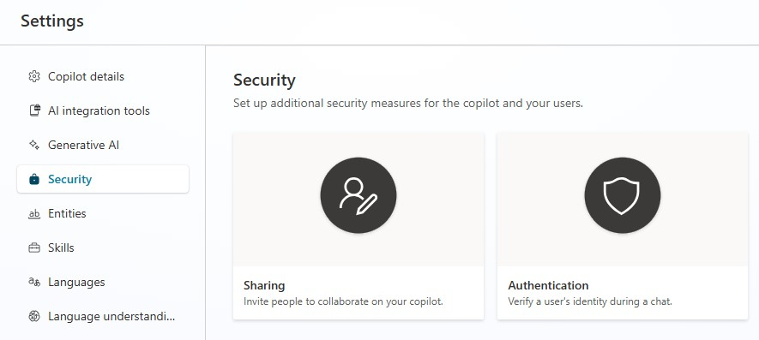

1. In the Authentication window, click on No Authentication then click on Save.

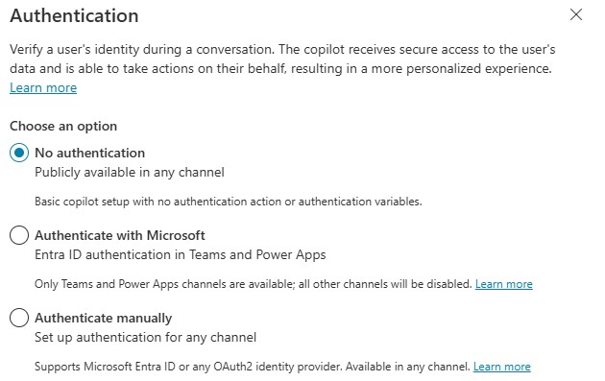

1. You will get a message regarding the changes, click **Save.**

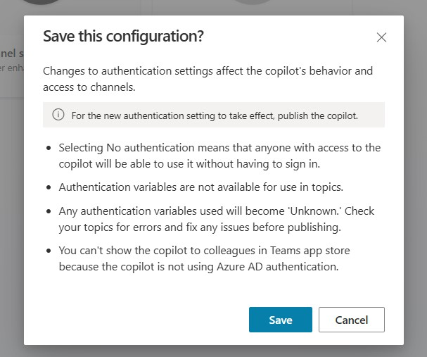

1. **Close** the **Security** and **Settings** windows.

6.

Go to the

**Overview**

tab on the

upper ribbon.

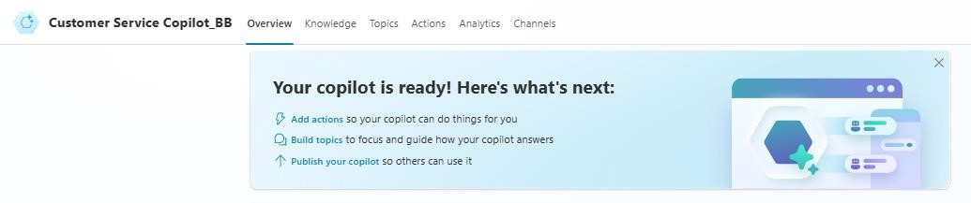

1. Scroll down to **Publish** **status** section to push the latest copilot topics to the demo website. You need to do this before you use the demo site the first time. You also need to publish after you make changes to the copilot topics that you want people to test on the demo website. (When you've created your real copilot, you publish each time you want to make updated topics available to your customers.)

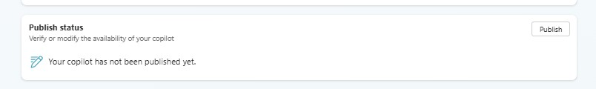

1. Select **Publish** in the dialog to confirm **Publish latest content?**

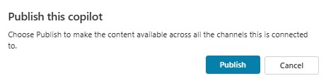

The publishing process checks for errors in the copilot topics whose Status is On. Publication should take only a few minutes.

You see a message at the top of the screen when publishing is complete.

1. Select the link for the **demo website**.

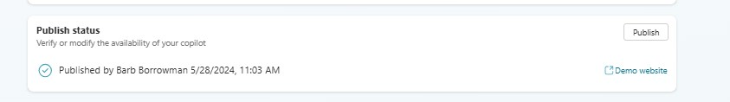

1. When the demo site window opens, you can interact with the copilot canvas by typing at the **Type your message** prompt or by selecting a starter phrase from the provided options.

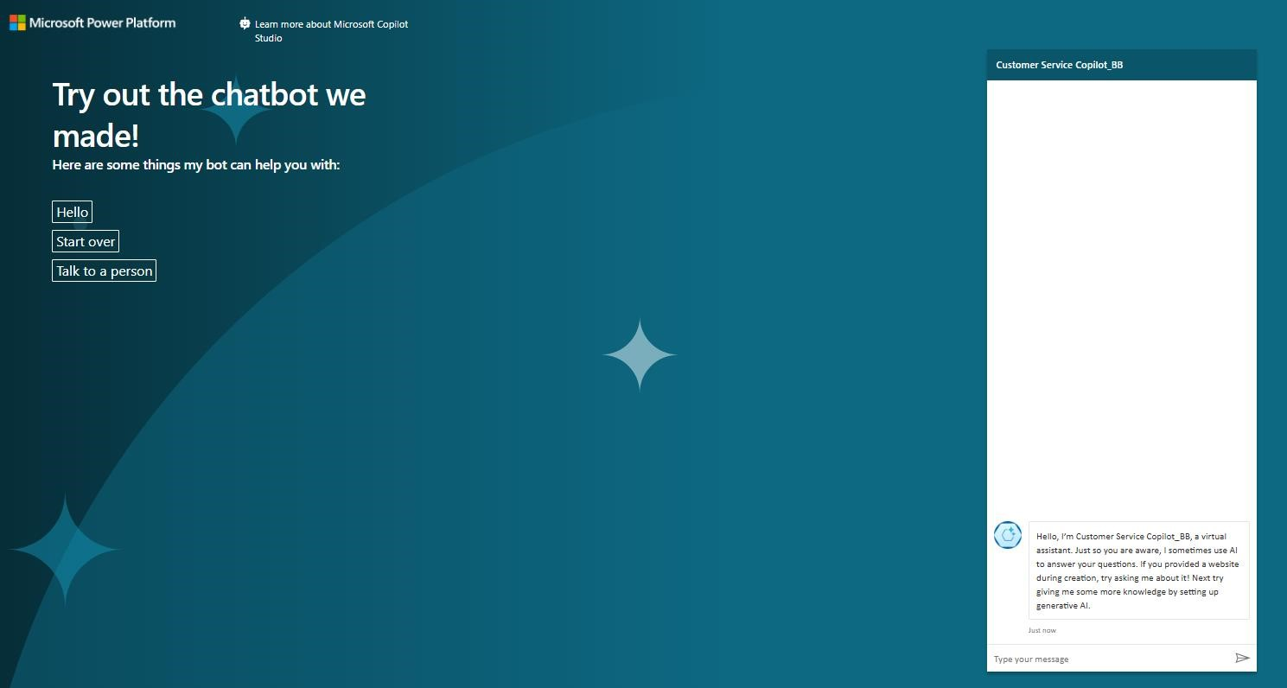

1. You can share the URL of the **demo website** with your team.

**Summary:**

In this lab, you have learned to build, test and publish a copilot.